Contexto histórico:
Teoria de jogos
Prisioners dillema

Prisioners dillema
Como funciona
Estratégias
Torneio
GA
Como funciona
Mutação
Geração seguinte
Populações:
Global measurments:
Average dgree
Cluster coefficient
Average path length
Small World Network
Cluster coefficient alto
Average path length baixo
Regular latice network ( 2D)
Cluster coefficient alto
Average path length alto
Random Network
Cluster coefficient alto
Average path length baixo

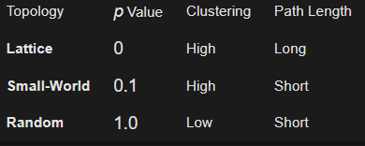

Resultados:

Avaliação individual:
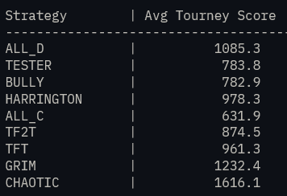

Razão para não corresponder aos testes de Axelord
your "Environment" is much more hostile than Axelrod's was.
Here is the evidence-based analysis of why TFT (Tit-for-Tat) is currently being outperformed by ALL_D, GRIM, and CHAOTIC in your specific setup.
In your population of 10 strategies, 40% are pure Nasty (ALL_D, Tester, Bully, Harrington) and 20% are Chaotic.
The Math of Exploitation: If TFT plays 10 opponents and 6 of them are "unreliable" or "nasty," TFT spends more than half its life in "retaliation mode."

In a retaliation cycle (D→D), TFT only gets 1 point.
Meanwhile, ALL_D gets 5 points every time it hits ALL_C or the first move of TFT

The "Chaos" Factor (The Biggest Difference)
Axelrod did not have a Logistic Map Chaotic strategy. This is the most likely "TFT-Killer" in your simulation.
- Pattern Recognition: TFT's strength is that it is Clear. It teaches the opponent: "If you are nice, I am nice."
- The Problem: A Chaotic player doesn't care about your lessons. It defects randomly (or pseudo-randomly).
- The Result: TFT gets "trapped" in a loop of retaliating against a Chaotic player who isn't even paying attention to the retaliation. This drives TFT's score down to the "Mutual Defection" level (1 point), while the Chaotic player might get lucky "Sucker" payoffs (5 points) periodically.
Why GRIM is Winning (For Now) on Nice
In your results, GRIM (1242.20) beat TFT (945.66).
- Evidence: In a world with "Testers" and "Harringtons," TFT is actually too nice. TFT retaliates once, but then it is willing to forgive. A "Tester" can exploit TFT, take a hit, and then maybe exploit again later.
- GRIM is a "Wall": GRIM tells the Nasty strategies: "You get one chance. If you probe me, the game is over for both of us." By being unforgiving, GRIM effectively "shuts down" the Nasty strategies' ability to extract points over the 200 rounds, making it more efficient than TFT in a high-crime environment.

The "Second Experiment" Logic (Variable Rounds)
You mentioned that in Axelrod’s second experiment (variable rounds), TFT still won. But there is a crucial detail: In Axelrod's second round, people knew the results of the first round. Most entrants submitted "Nice" strategies because they saw TFT win. Because the population became mostly Nice, TFT had more opportunities to score 3 points (Coop-Coop) than it had to suffer 0 points (Sucker).

